Student Name………………………………………….

Student Number ………………………………………

You must answer the questions posed on the following worksheet and show them to your tutor. You must also demonstrate the setup to the tutor and have a mark recorded.

You must work in pairs

Workshop 3.1

Objectives:
- Setup your LAN and connect it to your local router
- Connect 2 LANs via a WAN link
- Test for connectivity

Scenario
Your company has two sites in Telford and Wolverhampton, each requiring a LAN to be setup at the site and for WAN link to be enabled between them.

S0/0/0
S0/0/1

TELFORD
WOLVES

205.19.223.0 / 30
G0/0
G0/0

Ethernet switch

.

Telford
199.67.2.0/24
Wolves
192.168.6.0/24

Fig 1 Network set up for workshop 3.1

Student 1 configuring the WOLVES router :
Student 2 configuring the TELFORD router :

Working in pairs you are to decide who is TELFORD and other to WOLVES,

- Cable up your workstation to a switch, then into the Ethernet port G0/0 of your router.

- Use a serial cable between the serial ports of the routers. This cable is directional and the end with the DCE marked on it must go into the S0/0/0(serial 0) port of the WOLVES router

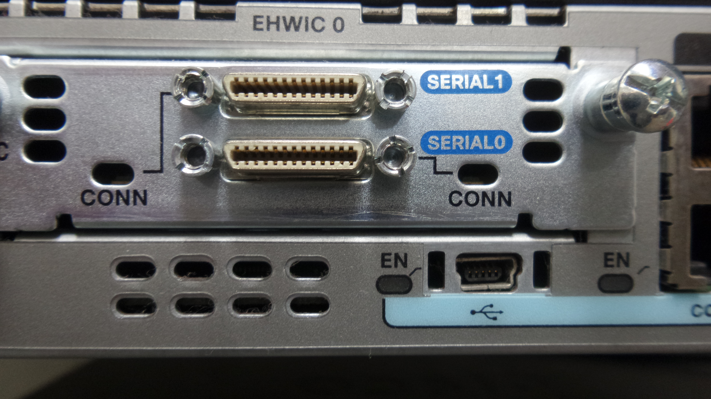

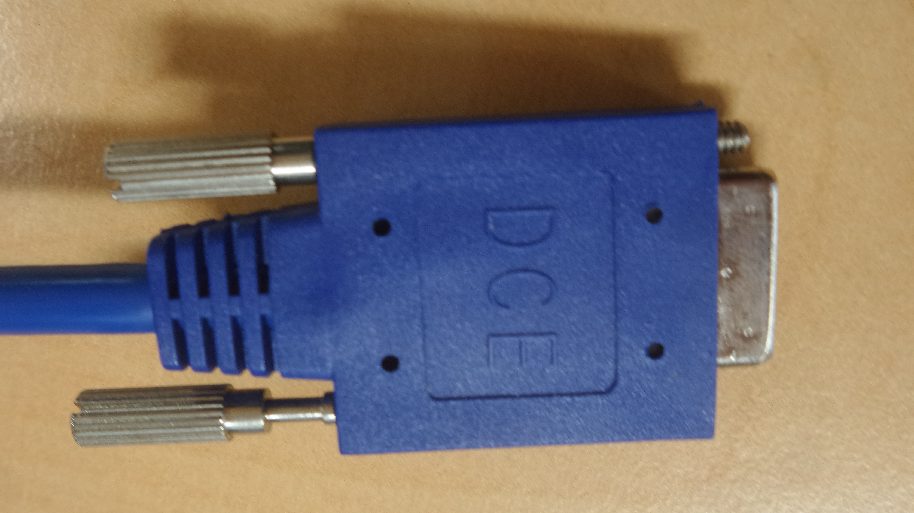

Set up the networks with the following configurations using the techniques you used in workshop 2. The steps for setting up the WAN links are shown after the table 1.
Table 1 – Settings to be configured on each router

Configuration setting | WOLVES | TELFORD
Router Hostname | WOLVES | TELFORD
Ethernet interface G0/0 | 192.168.6.1 | 199.67.2.1
Subnet mask for G0/0 | 255.255.255.0 | 255.255.255.0
Serial Port S0/0/0 | 205.19.223.1
Serial Port S0/0/1 |  | 205.19.223.2
Subnet mask for serial ports | 255.255.255.252 | 255.255.255.252
Clockrate for Wolves S0/0/0 | 56000

Configuring the Router

The WOLVES router requires the following configuration settings as it is the interface that issues the clock signal for synchronization between it and the S0/1 interface on the TELFORD router.

WOLVESXX(config)#Interface S0/0/0

WOLVESXX(config-if)#clockrate 56000

WOLVESXX(config-if)#no shutdown

Now each router needs to have routing protocol activated on it to do this you need to step down to the configuration level only. Now issue the following command:

WOLVESXX(config)#router RIP

And the prompt changes to

WOLVES (config-router)#

The routing protocol RIP needs to inform routers connected to it of any networks that it is connected to, this is called advertising its networks. The networks each router should advertise are shown in the table below.

Networks to advertise
WOLVES | TELFORD
192.168.6.0 | 199.67.2.0
205.19.223.0 | 205.19.223.0

For each router the network command will advertise a network

WOLVES (config-router)#network AAA.BBB.CCC.DDD

Where AAA.BBB.CCC.DDD is the address of the network you wish to advertise. Do this for both routers for the 2 networks that each needs to advertise.

Now PING between a host on the WOLVES network to one on the TELFORD network.

.
Tutor Signature ………………………………………..
Workshop 3.2

Objectives:
- Wire up and configure the network with following networks attached.
- Test for connectivity

S0/0/1
S0/0/0
TPARISYY
TIPTONXX

201.12.23.0 / 30
G0/0
G0/0

Ethernet switch

.

Paris
203.18.5.0/24
Tipton
200.45.6.0/24

Fig 3.2

Test for connectivity with the PING command and demonstrate this to your tutor to get it signed off.

Demonstrate to our tutor

Research areas
- routed protocol, routing protocol, RIP and its features, routers and packet handling, subnet masks, how is a subnet mask used by a router. Structure of IP address. Definitions of collision and broadcast domains.

